

**ATSS’s**

**Institute of Industrial & Computer Management & Research, Nigdi**

**Academic Year 2023-2024**

**MCA II**

# **MASTER OF COMPUTER APPLICATION SAVITRIBAI PHULE PUNE UNIVERSITY**

**PROJECT REPORT ON**

**“Film Finder”**

|  |  |  |  |
| --- | --- | --- | --- |
| **Sr.No** | **Topic** | **Page** | **Remark** |
| **1** | **CHAPTER 1: INTRODUCTION** |  |  |
|  | 1.1 Existing System |  |  |
|  | 1.2 Need for System |  |  |
|  | 1.3 Scope of Work |  |  |
|  | 1.4 Operating Environment – Hardware and Software |  |  |
|  | 1.5 Detail Description of Technology Used |  |  |
| **2** | **CHAPTER 2: PROPOSED SYSTEM** |  |  |
|  | 2.1 Proposed system |  |  |
|  | 2.2 Objective of System |  |  |
|  | 2.3 User Requirement |  |  |
| **3** | **CHAPTER 3: ANALYSIS AND DESIGN** |  |  |
|  | 3.1 Architecture Diagram |  |  |
|  | 3.2 Sequence Diagram |  |  |
|  | 3.3 Use Case Diagram |  |  |
|  | 3.4 Component Diagram |  |  |
|  | 3.5 User Interface Design |  |  |
| **4** | **CHAPTER 4: USER MANUAL** |  |  |
|  | 4.1 Drawback and Limitations |  |  |
|  | 4.2 Proposed Enhancements |  |  |
|  | 4.3 Bibliography |  |  |
|  | **ANNEXURES** |  |  |
|  | ANNEXURE 1 : USER INTERFACE SCREENS |  |  |
|  | ANNEXURE 2 : OUTPUT REPORTS WITH DATA ( if any ) |  |  |
|  | ANNEXURE 3 : SAMPLE PROGRAM CODE |  |  |

**CHAPTER 1 : INTRODUCTION**

* 1. Existing System:
* Users have to physically choose movies from libraries.
* Options included reading user reviews or randomly selecting a movie.
* Impractical due to the vast number of spectators with diverse movie preferences.
* System suggests to us what to watch without having to put effort into deciding what to watch.
  1. **Need for System:**
* **Diverse Preferences:** People have diverse tastes and preferences when it comes to movies. A recommender system helps in tailoring content recommendations to individual users, considering their viewing history, ratings, and preferences**.**
* **Vast Content Libraries:** Streaming platforms often have vast libraries of movies and TV shows. Recommender systems help users discover hidden gems and navigate through the extensive content catalog, making it easier to find content they might enjoy.
* **Enhanced User Satisfaction:** When users find content that aligns with their preferences, they are more likely to be satisfied with the platform's service. This satisfaction contributes to customer retention.
* **Differentiation:** A well-designed recommender system can set a platform apart from its competitors by offering a superior and more personalized user experience.
  1. Scope of Work
* Accurate movie recommendations to users.
* **Goal**: To improve the quality of movie recommendation system, such as accuracy, quality and scalability of system than the pure approaches. This is done using Hybrid approach by combining content based filtering and collaborative filtering,
* Eradicate the overload of the data, recommendation system is used as information filtering tool in social networking sites. Hence, there is a huge scope of exploration in this field for improving scalability, accuracy and quality of movie recommendation systems.
  1. Operating Environment –

Hardware:

Processor: Intel core Processor Pentium 4  
Operating System: Windows 7 and Above  
RAM: 2GB and Above  
Hard Disk: 40GB and Above

Software:

**Frontend:** Html, CSS, Javascript

**Frame Work:** Flask

**Language:** Python 3.11

**API:** TMDB

* 1. Detail Description of Technology Used
* HTML

HTML stands for Hyper Text Mark-up Language.

HTML is the standard markup language for creating Web pages.

HTML describes the structure of a Web  
page.

HTML consists of a series of elements.

HTML elements tell the browser how to display the content.

HTML elements label pieces of content such as "this is a heading", "this is a paragraph", "this is a link", etc.

• **CSS**CSS stands for Cascading Style Sheets. CSS describes how HTML  
elements are to be displayed on screen, paper, or in other media. CSS saves  
a lot of work. It can control the layout of multiple web pages all atonce.  
External style sheets are stored in CSS files.

• **JavaScript**It's the most popular programming language. It's in your browser.JavaScript  
also exists outside of the internet. JavaScript is Ideal for Newbies. JavaScript  
is Easy to Learn. You Can Create Visual Effects and Other Eye-catching.  
Aesthetic Features. JavaScript is Versatile.

* **Python**

Python is a high-level, general-purpose programming language. Its design philosophy emphasizes code readability with the use of significant indentation. Python is dynamically typed and garbage-collected. It supports multiple programming paradigms, including structured (particularly procedural), object-oriented and functional programming. It is often described as a "batteries included" language due to its comprehensive standard library.

* **Flask**:

Flask is a micro web framework written in Python. It is classified as a microframework because it does not require particular tools or libraries. It has no database abstraction layer, form validation, or any other components where pre-existing third-party libraries provide common functions. However, Flask supports extensions that can add application features as if they were implemented in Flask itself. Extensions exist for object-relational mappers, form validation, upload handling, various open authentication technologies and several common framework related tools.

* API:

API stands for Application Programming Interface. In the context of APIs, the word Application refers to any software with a distinct function. Interface can be thought of as a contract of service between two applications. This contract defines how the two communicate with each other using requests and responses.

**CHAPTER 2 : PROPOSED SYSTEM**

2.1 Proposed System:

* Content-Based Filtering:

It considers the characteristics of movies, such as genre, director, and actors, to recommend items that are similar to those a user has liked in the past.

* Integration with External Data Sources:

It integrate external data sources, such as movie databases or APIs(TMDB), to enrich its catalog of movies and ensure up-to-date information.

* Sentiments:

Allowing users to view explicit feedback/reaction on recommended movies.

2.2 Objectives of System:

The Movie Recommendation System provides a mechanism to help users categorize users

with similar interests. Basically the purpose of a recommendation system is to search for

material that will be interesting to a person. Moreover, it involves a number of factors to

create personalized lists of useful and interesting content specific to each user/individual.

Recommendation algorithm collects from the user interest. A set of keywords (or

features) of an item is the Item profile. For example, consider a scenario in which a

person goes to buy his favorite cake ‘X’ to a pastry. Unfortunately, cake ‘X’ has been sold

out and as a result of this the shopkeeper recommends the person to buy cake ‘Y’ which is

made up of ingredients similar to cake ‘X’

The Movie Recommendation System provides a mechanism to help users categorize users

with similar interests. Basically the purpose of a recommendation system is to search for

material that will be interesting to a person. Moreover, it involves a number of factors to

create personalized lists of useful and interesting content specific to each user/individual.

Recommendation algorithm collects from the user interest. A set of keywords (or

features) of an item is the Item profile. For example, consider a scenario in which a

person goes to buy his favorite cake ‘X’ to a pastry. Unfortunately, cake ‘X’ has been sold

out and as a result of this the shopkeeper recommends the person to buy cake ‘Y’ which is

made up of ingredients similar to cake ‘X’

A mechanism to help users categorize users with similar interests. Basically the purpose of a recommendation system is to search for material that will be interesting to a person. Moreover, it involves a number of factors to create personalized lists of useful and interesting content specific to each user/individual. Recommendation algorithm collects from the user interest. A set of keywords (or features) of an item is the Item profile. For example, consider a scenario in which a person goes to buy his favorite cake ‘X’ to a pastry. Unfortunately, cake ‘X’ has been sold out and as a result of this the shopkeeper recommends the person to buy cake ‘Y’ which is made up of ingredients similar to cake ‘X’

2.3 User Requirements:

**CHAPTER 3 : ANALYSIS & DESIGN**

3.1 Architecture Diagram:

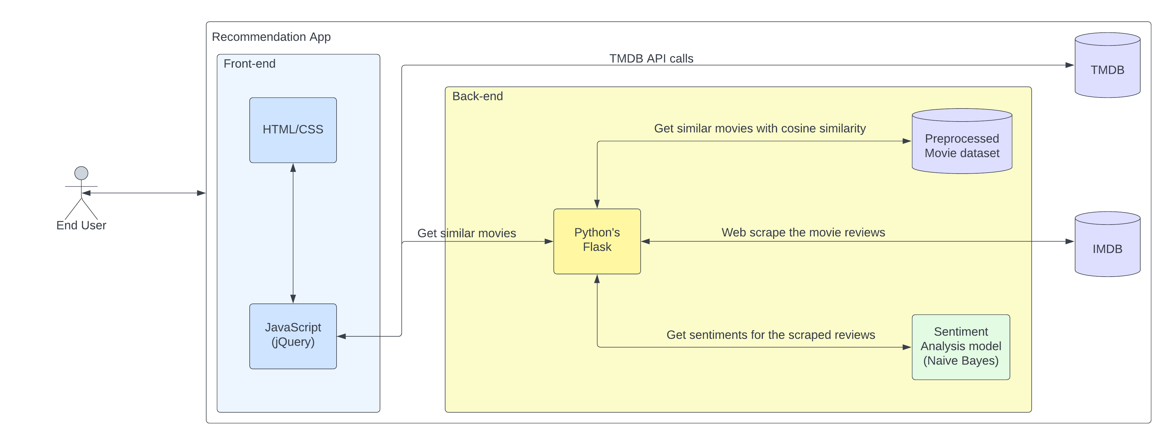

3.2 Sequence Diagram: 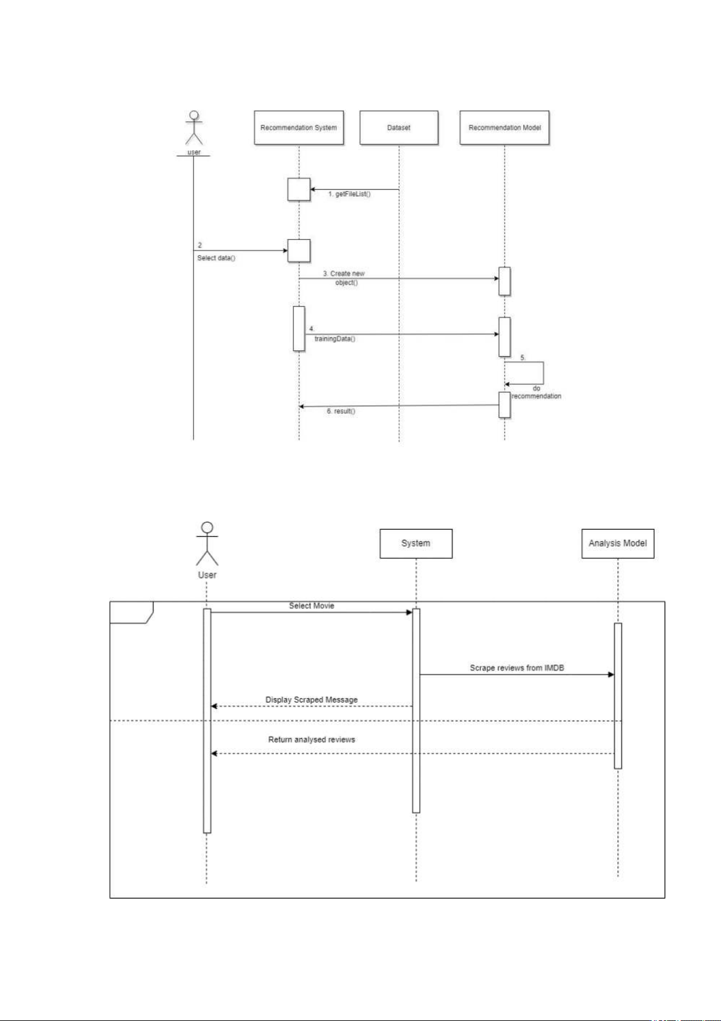

3.3 Use Case Diagrams:

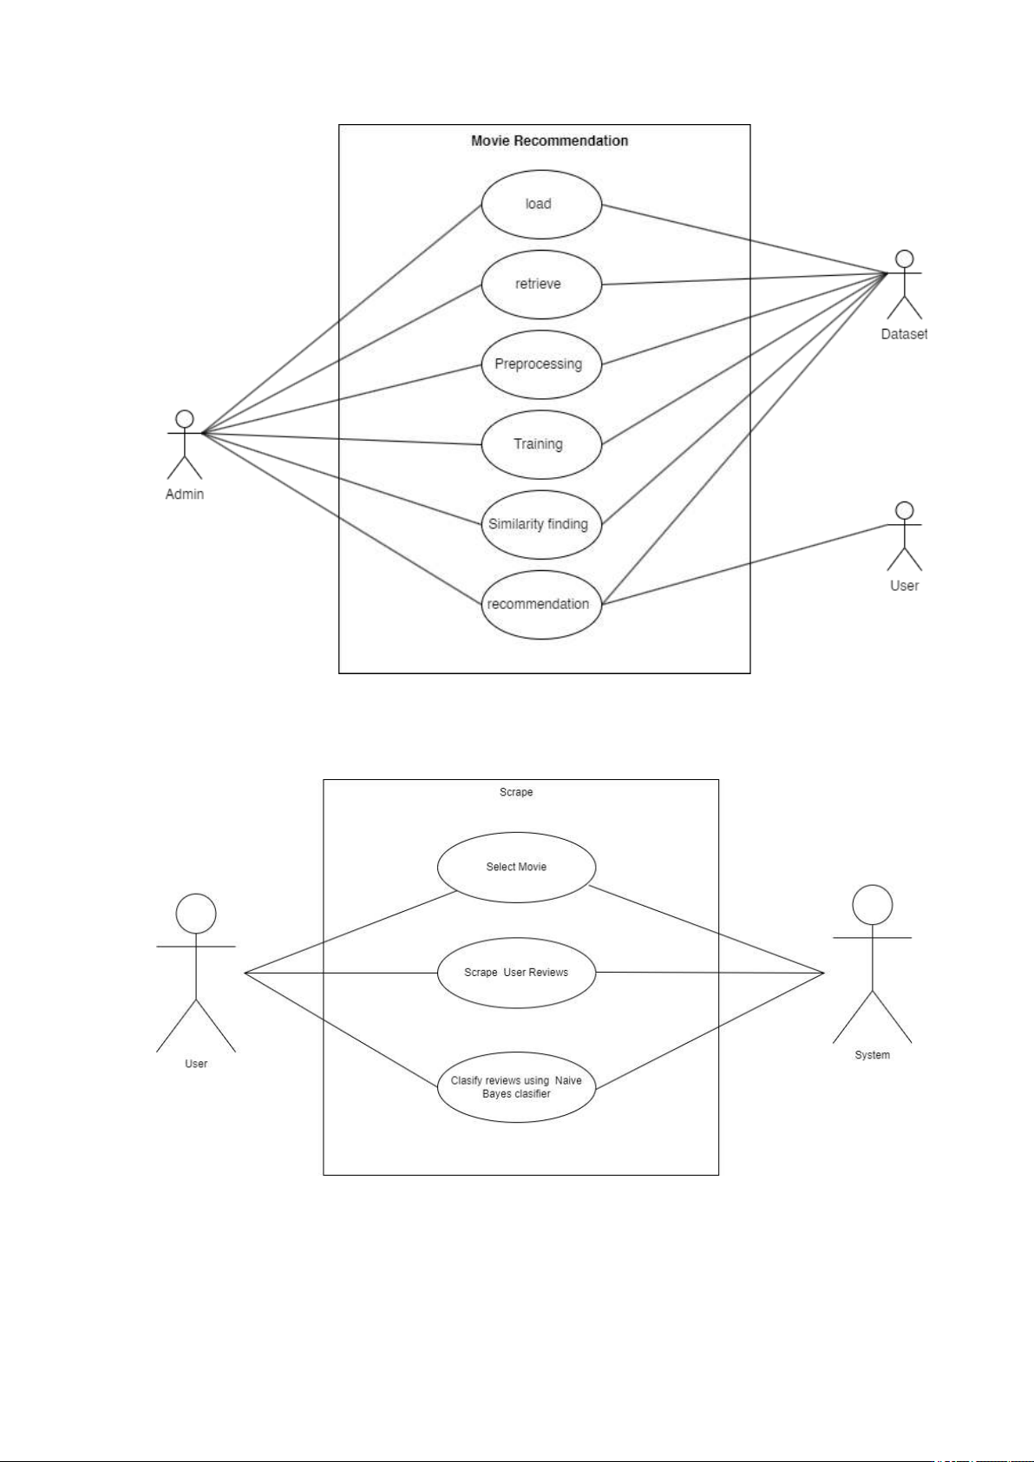

3.4 Component diagram:

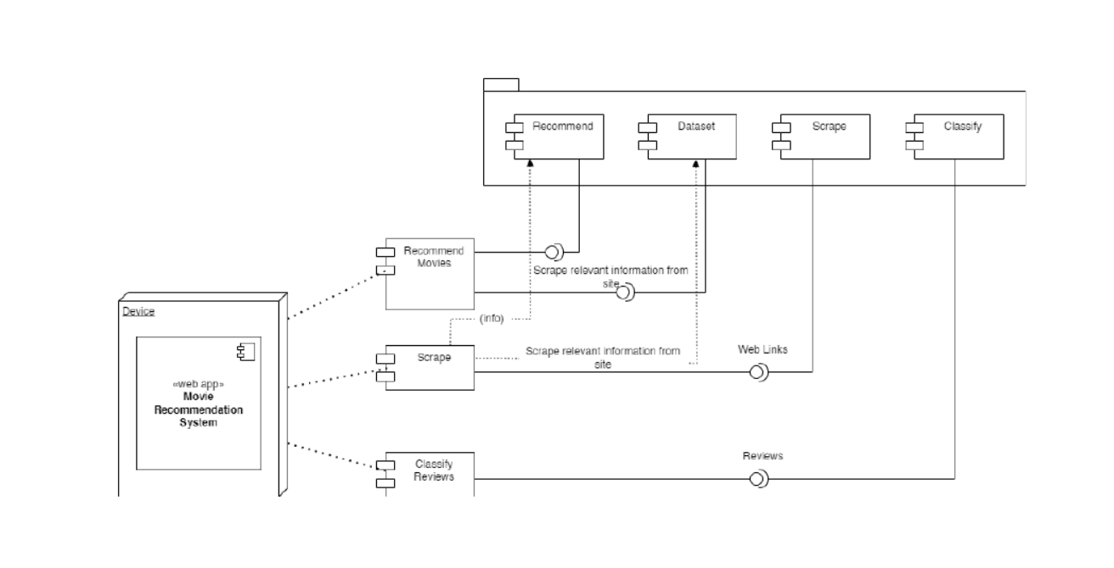

3.5 DFD diagram:

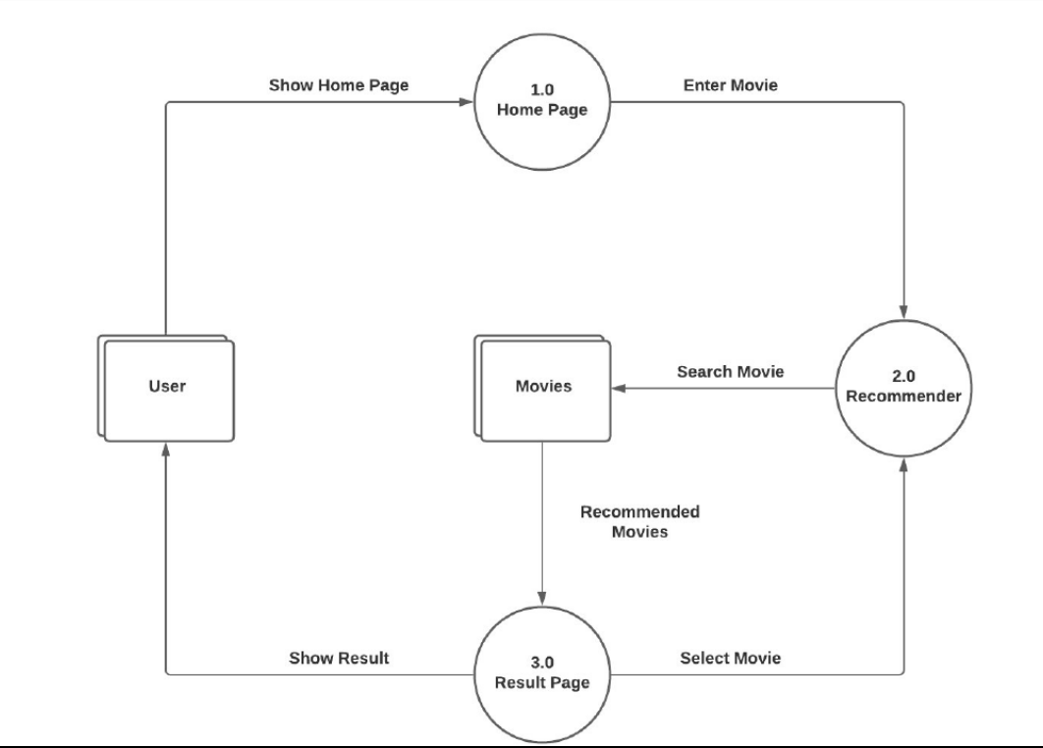

3.5 User Interface Design (Screens etc.)

Home Page:

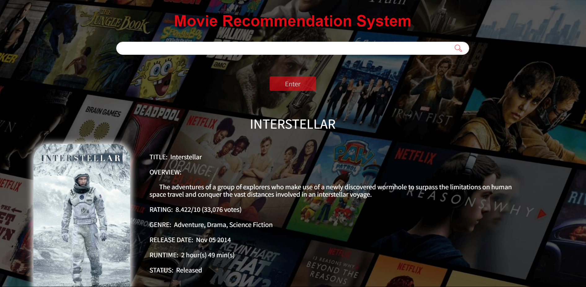

Review System:

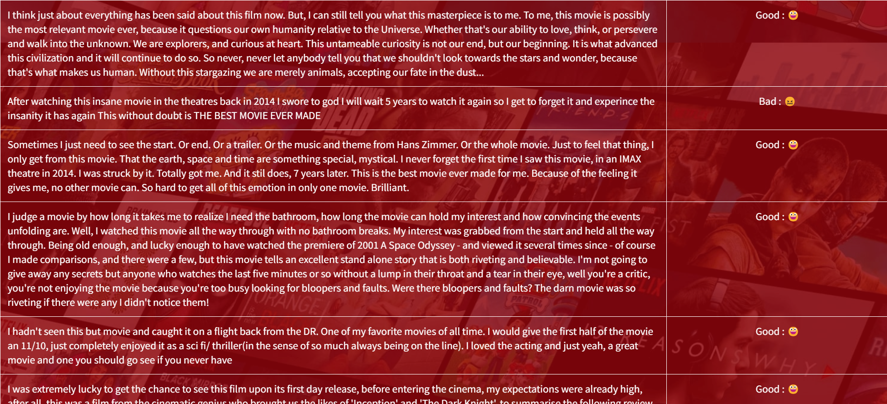

Cast System:

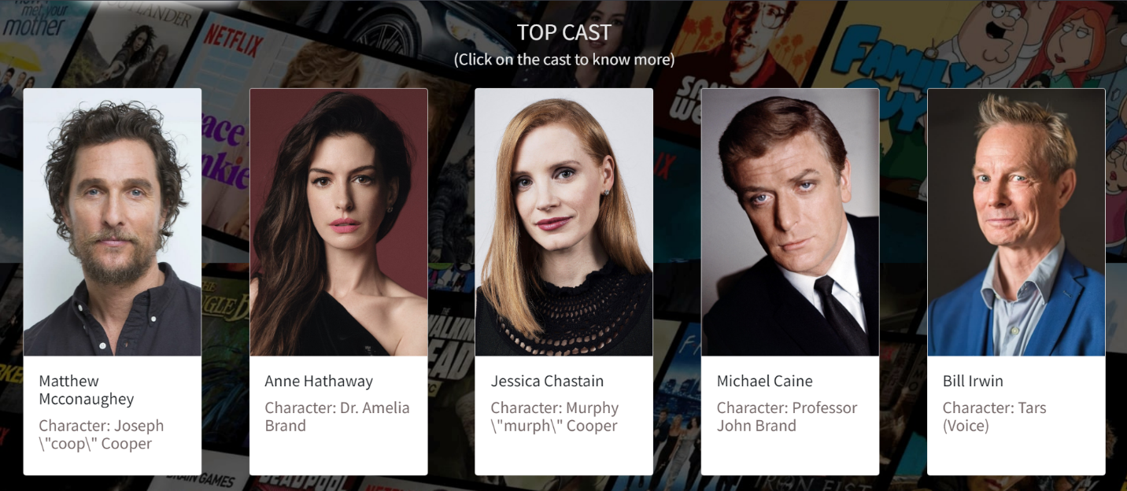

Recommend System:

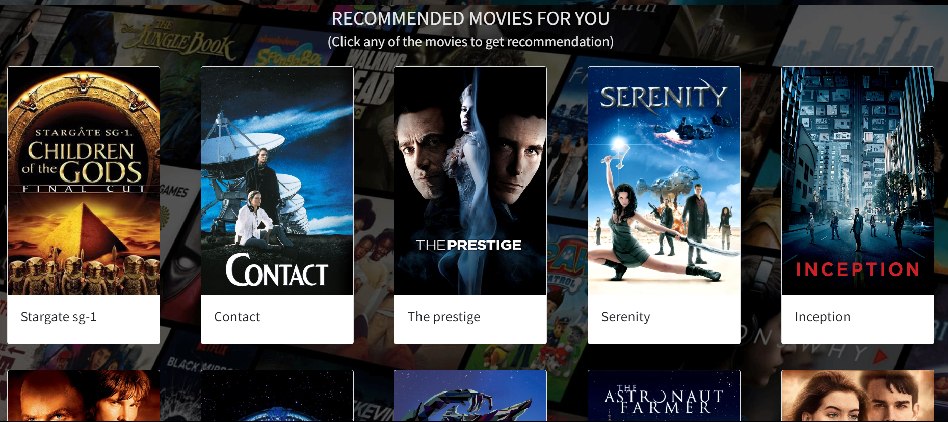

**CHAPTER 4: USER MANUAL**

Drawbacks and Limitations:

Proposed Enhancements:

Bibliography :

Websites**:**• https://www.tutorialspoint.com/jsp/index.html  
• https://www.stackoverflow.com/  
• https://www.geekforgeeks.com/

**ANNEXURES**:

ANNEXURE 1 : USER INTERFACE SCREENS

Homepage:



Review page:



Cast Page:



Other Screens:

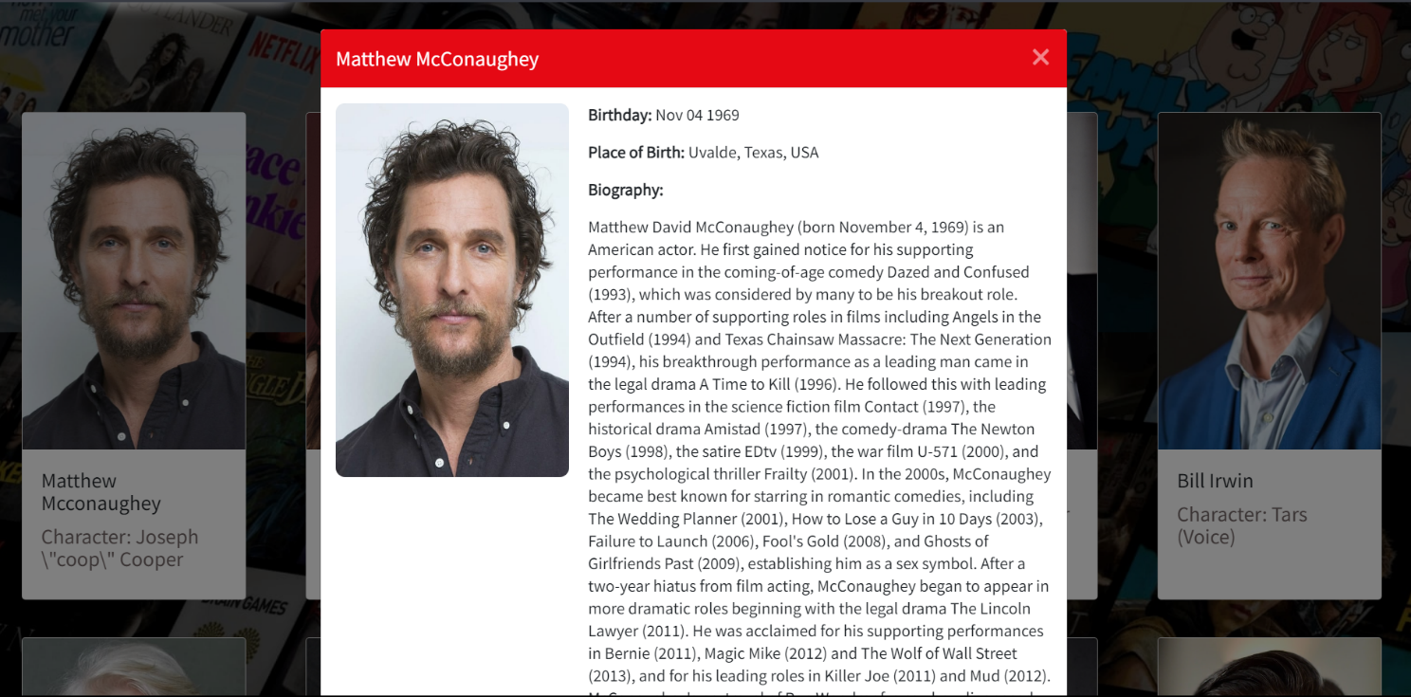

ANNEXURE 2 : OUTPUT REPORTS WITH DATA ( if any )

Reviews using Sentiement anyalsis:



ANNEXURE 3 : SAMPLE PROGRAM CODE

1.Main.py:

import numpy as np

import pandas as pd

from flask import Flask, render_template, request

from sklearn.feature_extraction.text import CountVectorizer

from sklearn.metrics.pairwise import cosine_similarity

import json

import bs4 as bs

import urllib.request

import pickle

import requests

# load the nlp model and tfidf vectorizer from disk

filename = 'nlp_model.pkl'

clf = pickle.load(open(filename, 'rb'))

vectorizer = pickle.load(open('tranform.pkl','rb'))

def create_similarity():

data = pd.read_csv('main_data.csv')

# creating a count matrix

cv = CountVectorizer()

count_matrix = cv.fit_transform(data['comb'])

# creating a similarity score matrix

similarity = cosine_similarity(count_matrix)

return data,similarity

def rcmd(m):

m = m.lower()

try:

data.head()

similarity.shape

except:

data, similarity = create_similarity()

if m not in data['movie_title'].unique():

return('Sorry! The movie you requested is not in our database. Please check the spelling or try with some other movies')

else:

i = data.loc[data['movie_title']==m].index[0]

lst = list(enumerate(similarity[i]))

lst = sorted(lst, key = lambda x:x[1] ,reverse=True)

lst = lst[1:11] # excluding first item since it is the requested movie itself

l = []

for i in range(len(lst)):

a = lst[i][0]

l.append(data['movie_title'][a])

return l

# converting list of string to list (eg. "["abc","def"]" to ["abc","def"])

def convert_to_list(my_list):

my_list = my_list.split('","')

my_list[0] = my_list[0].replace('["','')

my_list[-1] = my_list[-1].replace('"]','')

return my_list

def get_suggestions():

data = pd.read_csv('main_data.csv')

return list(data['movie_title'].str.capitalize())

app = Flask(__name__)

@app.route("/")

@app.route("/home")

def home():

suggestions = get_suggestions()

return render_template('home.html',suggestions=suggestions)

@app.route("/similarity",methods=["POST"])

def similarity():

movie = request.form['name']

rc = rcmd(movie)

if type(rc)==type('string'):

return rc

else:

m_str="---".join(rc)

return m_str

@app.route("/recommend",methods=["POST"])

def recommend():

# getting data from AJAX request

title = request.form['title']

cast_ids = request.form['cast_ids']

cast_names = request.form['cast_names']

cast_chars = request.form['cast_chars']

cast_bdays = request.form['cast_bdays']

cast_bios = request.form['cast_bios']

cast_places = request.form['cast_places']

cast_profiles = request.form['cast_profiles']

imdb_id = request.form['imdb_id']

poster = request.form['poster']

genres = request.form['genres']

overview = request.form['overview']

vote_average = request.form['rating']

vote_count = request.form['vote_count']

release_date = request.form['release_date']

runtime = request.form['runtime']

status = request.form['status']

rec_movies = request.form['rec_movies']

rec_posters = request.form['rec_posters']

# get movie suggestions for auto complete

suggestions = get_suggestions()

# call the convert_to_list function for every string that needs to be converted to list

rec_movies = convert_to_list(rec_movies)

rec_posters = convert_to_list(rec_posters)

cast_names = convert_to_list(cast_names)

cast_chars = convert_to_list(cast_chars)

cast_profiles = convert_to_list(cast_profiles)

cast_bdays = convert_to_list(cast_bdays)

cast_bios = convert_to_list(cast_bios)

cast_places = convert_to_list(cast_places)

# convert string to list (eg. "[1,2,3]" to [1,2,3])

cast_ids = cast_ids.split(',')

cast_ids[0] = cast_ids[0].replace("[","")

cast_ids[-1] = cast_ids[-1].replace("]","")

# rendering the string to python string

for i in range(len(cast_bios)):

cast_bios[i] = cast_bios[i].replace(r'\n', '\n').replace(r'\"','\"')

# combining multiple lists as a dictionary which can be passed to the html file so that it can be processed easily and the order of information will be preserved

movie_cards = {rec_posters[i]: rec_movies[i] for i in range(len(rec_posters))}

casts = {cast_names[i]:[cast_ids[i], cast_chars[i], cast_profiles[i]] for i in range(len(cast_profiles))}

cast_details = {cast_names[i]:[cast_ids[i], cast_profiles[i], cast_bdays[i], cast_places[i], cast_bios[i]] for i in range(len(cast_places))}

# web scraping to get user reviews from IMDB site

sauce = urllib.request.urlopen('https://www.imdb.com/title/{}/reviews?ref_=tt_ov_rt'.format(imdb_id)).read()

soup = bs.BeautifulSoup(sauce,'lxml')

soup_result = soup.find_all("div",{"class":"text show-more__control"})

reviews_list = [] # list of reviews

reviews_status = [] # list of comments (good or bad)

for reviews in soup_result:

if reviews.string:

reviews_list.append(reviews.string)

# passing the review to our model

movie_review_list = np.array([reviews.string])

movie_vector = vectorizer.transform(movie_review_list)

pred = clf.predict(movie_vector)

reviews_status.append('Good' if pred else 'Bad')

# combining reviews and comments into a dictionary

movie_reviews = {reviews_list[i]: reviews_status[i] for i in range(len(reviews_list))}

# passing all the data to the html file

return render_template('recommend.html',title=title,poster=poster,overview=overview,vote_average=vote_average,

vote_count=vote_count,release_date=release_date,runtime=runtime,status=status,genres=genres,

movie_cards=movie_cards,reviews=movie_reviews,casts=casts,cast_details=cast_details)

if __name__ == '__main__':

app.run(debug=True)

**Autocomplete.js:**

new autoComplete({

data: { // Data src [Array, Function, Async] | (REQUIRED)

src: films,

},

selector: "#autoComplete", // Input field selector | (Optional)

threshold: 2, // Min. Chars length to start Engine | (Optional)

debounce: 100, // Post duration for engine to start | (Optional)

searchEngine: "strict", // Search Engine type/mode | (Optional)

resultsList: { // Rendered results list object | (Optional)

render: true,

container: source => {

source.setAttribute("id", "food_list");

},

destination: document.querySelector("#autoComplete"),

position: "afterend",

element: "ul"

},

maxResults: 5, // Max. number of rendered results | (Optional)

highlight: true, // Highlight matching results | (Optional)

resultItem: { // Rendered result item | (Optional)

content: (data, source) => {

source.innerHTML = data.match;

},

element: "li"

},

noResults: () => { // Action script on noResults | (Optional)

const result = document.createElement("li");

result.setAttribute("class", "no_result");

result.setAttribute("tabindex", "1");

result.innerHTML = "No Results";

document.querySelector("#autoComplete_list").appendChild(result);

},

onSelection: feedback => { // Action script onSelection event | (Optional)

document.getElementById('autoComplete').value = feedback.selection.value;

}

**});**